

Certificate

This is to certify that **Ms. Dakhare Sneha Suresh** , **Mr. Karigavkar**

**Rishikesh** Reg no:-- 2020BEC010 AND 2020BEC018 ,of 6th Semester of

engineering in **Electronic and Telecommunication** of Institute, SHRI

GURU GOBIND SINGHJI INSTITUTE OF ENGINEERING AND TECHNOLOGY

NANDED has completed the **MINI PROJECT** satisfactorily in

Subject—MINI PROJECT for the academic year **2023—2024** as prescribed in the curriculum .

PLACE:-NANDED

DATE:-………………..

…………….

**Subject Teacher Head of Department**

## 

# Driver Drowsiness Detection System using Arduino | driver sleep detection and alarming system

Guided By:--

Submitted BY:--

NAME Roll No Registration no

1.Sneha B05 2020BEC010

Dakhare

2.Karigavkar 2020BEC018

Rishikesh

**Certificate**

This is certify that Ms .Dakahre Sneha Suresh, Mr Karigavkar

Rishikesh Reg No :- 2020BEC010 , 2020BEC016 has completed Project

# Planning Report having title “ Driver Drowsiness Detection System

# using Arduino | driver sleep detection and alarming system”

In a group consisting of two Candidates under the guidance of the

**Name of Guide:-**

**Name of HOD:-Dr . Bhalerao sir**

**Acknowledgement**

We are profoundly grateful to Dr. sir for his

expert guidance and continuous throughout to see that this

project rights its target since its commencement to its

completion. ………………….

ABSTRACT

This document is a review report on the research conducted and

the project made in the field of Electronic and telecommunication

to develop a system for driver drowsiness detection to prevent

accidents from happening because of driver fatigue and

sleepiness. The report proposed the results and solutions on the

limited implementation of the various techniques that are

introduced in the project.

Whereas the implementation of the project give the real world

idea of how the system works and what changes can be done in

order to improve the utility of the overall system.

Furthermore, the paper states the overview of the observations

made by the authors in order to help further optimization in the

mentioned field to achieve the utility at a better efficiency for a

safer road.

Keywords—Driver drowsiness; eye detection; yawn detection;

blink pattern; fatigue

**Contents**1 Introduction

1.1 PURPOSE   
1.1.1 HUMAN PSYCHOLOGY  
1.1.2 CURRENT STATISTICS   
1.2 INTENDED AUDIENCE  
1.3 PRODUCT SCOPE  
1.4 PROBLEM DEFINITION

2 Literature Survey

2.1 SYSTEM REVIEW   
2.2 TECHNOLOGY USED

3 Software Requirements Specification

3.1 PYTHON   
3.1.1 LIBRARIES   
3.2 OPERATING SYSTEM   
3.3 HARDWARE

4 System Design

4.1 USE CASE MODEL   
4.2 ACTIVITY DIAGRAM

4.3 CLASS DIAGRAM

5 System Testing

5.1 TEST CASES & TEST RESULTS

6 Project Planning 18

6.1 SYSTEM MODEL

7 Implementation 19

8 Screenshots of Project

8.1 NON-DROWSY STATE   
8.2 DROWSY STATE

9 Conclusion and Future Scope

9.1 CONCLUSION   
9.2 FUTURE SCOPE

10 References

Chapter 1  
 Introduction

1.1 PURPOSE

1.1.1 HUMAN PSYCHOLOGY WITH CURRENT TECHNOLOGY

Humans have always invented machines and devised techniques to ease  
and protect their lives, for mundane activities like traveling to work, or for  
more interesting purposes like aircraft travel. With the advancement in  
technology, modes of transportation kept on advancing and our  
dependency on it started increasing exponentially. It has greatly affected  
our lives as we know it. Now, we can travel to places at a pace that even  
our grandparents wouldn’t have thought possible. In modern times, almost  
everyone in this world uses some sort of transportation every day. Some  
people are rich enough to have their own vehicles while others use public  
transportation. However, there are some rules and codes of conduct for  
those who drive irrespective of their social status. One of them is staying  
alert and active while driving.

Neglecting our duties towards safer travel has enabled hundreds of  
thousands of tragedies to get associated with this wonderful invention  
every year. It may seem like a trivial thing to most folks but following rules  
and regulations on the road is of utmost importance. While on road, an  
automobile wields the most power and in irresponsible hands, it can be  
destructive and sometimes, that carelessness can harm lives even of the  
people on the road. One kind of carelessness is not admitting when we  
are too tired to drive. In order to monitor and prevent a destructive  
outcome from such negligence, many researchers have written research  
papers on driver drowsiness detection systems. But at times, some of the  
points and observations made by the system are not accurate enough.  
Hence, to provide data and another perspective on the problem at hand,  
in order to improve their implementations and to further optimize the  
solution, this project has been done.

1.1.2 FACTS & STATISTICS

Our current statistics reveal that just in 2015 in India alone, 148,707  
people died due to car related accidents. Of these, at least 21 percent  
were caused due to fatigue causing drivers to make mistakes. This can be  
a relatively smaller number still, as among the multiple causes that can  
lead to an accident, the involvement of fatigue as a cause is generally  
grossly underestimated. Fatigue combined with bad infrastructure in  
developing countries like India is a recipe for disaster. Fatigue, in general,  
is very difficult to measure or observe unlike alcohol and drugs, which  
have clear key indicators and tests that are available easily. Probably, the  
best solutions to this problem are awareness about fatigue-related  
accidents and promoting drivers to admit fatigue when needed. The  
former is hard and much more expensive to achieve, and the latter is not  
possible without the former as driving for long hours is very lucrative.  
When there is an increased need for a job, the wages associated with it  
increases leading to more and more people adopting it. Such is the case  
for driving transport vehicles at night. Money motivates drivers to make  
unwise decisions like driving all night even with fatigue. This is mainly  
because the drivers are not themselves aware of the huge risk associated  
with driving when fatigued. Some countries have imposed restrictions on  
the number of hours a driver can drive at a stretch, but it is still not  
enough to solve this problem as its implementation is very difficult and  
costly.

1.2 INTENDED AUDIENCE

The intended audience for this document are the development team, the  
project evaluation jury, and other tech-savvy enthusiasts who wish to  
further work on the project.

1.3 PRODUCT SCOPE

There are many products out there that provide the measure of fatigue  
level in the drivers which are implemented in many vehicles. The driver  
drowsiness detection system provides the similar functionality but with  
better results and additional benefits. Also, it alerts the user on reaching a  
certain saturation point of the drowsiness measure.

1.4 PROBLEM DEFINITION

Fatigue is a safety problem that has not yet been deeply tackled by any  
country in the world mainly because of its nature. Fatigue, in general, is  
very difficult to measure or observe unlike alcohol and drugs, which have  
clear key indicators and tests that are available easily. Probably, the best  
solutions to this problem are awareness about fatigue-related accidents  
and promoting drivers to admit fatigue when needed. The former is hard  
and much more expensive to achieve, and the latter is not possible  
without the former as driving for long hours is very lucrative.

Chapter 2

Literature Survey

2.1 SYSTEM REVIEW

This survey is done to comprehend the need and prerequisite of the  
general population, and to do as such, we went through different sites and  
applications and looked for the fundamental data. Based on these data,  
we made an audit that helped us get new thoughts and make different  
arrangements for our task. We reached the decision that there is a need  
of such application and felt that there is a decent extent of progress in this  
field too.

2.2 TECHNOLOGY USED

a. **PYTHON** - Python is an interpreted, high-level, general-purpose  
programming language. Python's design philosophy emphasizes code  
readability with its notable use of significant whitespace. Its language  
constructs and object-oriented approach aim to help programmers write  
clear, logical code for small and large-scale projects. Python is  
dynamically typed AND supports multiple programming paradigms,  
including procedural, object-oriented, and functional programming.

b. **MACHINE LEARNING** - Machine learning is the scientific  
study of algorithms and statistical models that computer systems use in  
order to perform a specific task effectively without using explicit  
instructions, relying on patterns and inference instead. It is seen as a  
subset of artificial intelligence. Machine learning algorithms build  
a mathematical model based on sample data, known as "training data",  
in order to make predictions or decisions without being explicitly told.

Chapter 3

Software Requirements Specification  
3.1 Python:

• Python 3.9

3.2 Libraries

• Numpy: Pre-requisite for Dlib  
• Dlib: This program is used to find the frontal human face and  
 estimate its pose using 68 face landmarks.  
• Imutils: Convenient functions written for Opencv.  
• opencv: Used to get the video stream from the webcam etc.

3.3 Operating System  
• Windows

Hardware Requirements Specification

I. Laptop.

Chapter 5

System Design

5.1 USE CASE DIAGRAM

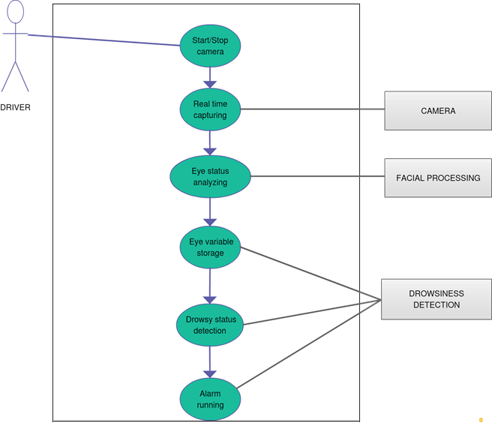

5.2 ACTIVITY DIAGRAM:

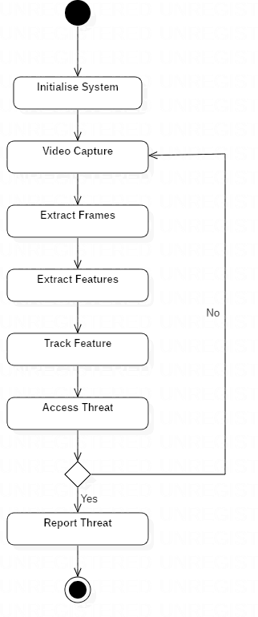

5.3 CLASS DIAGRAM:

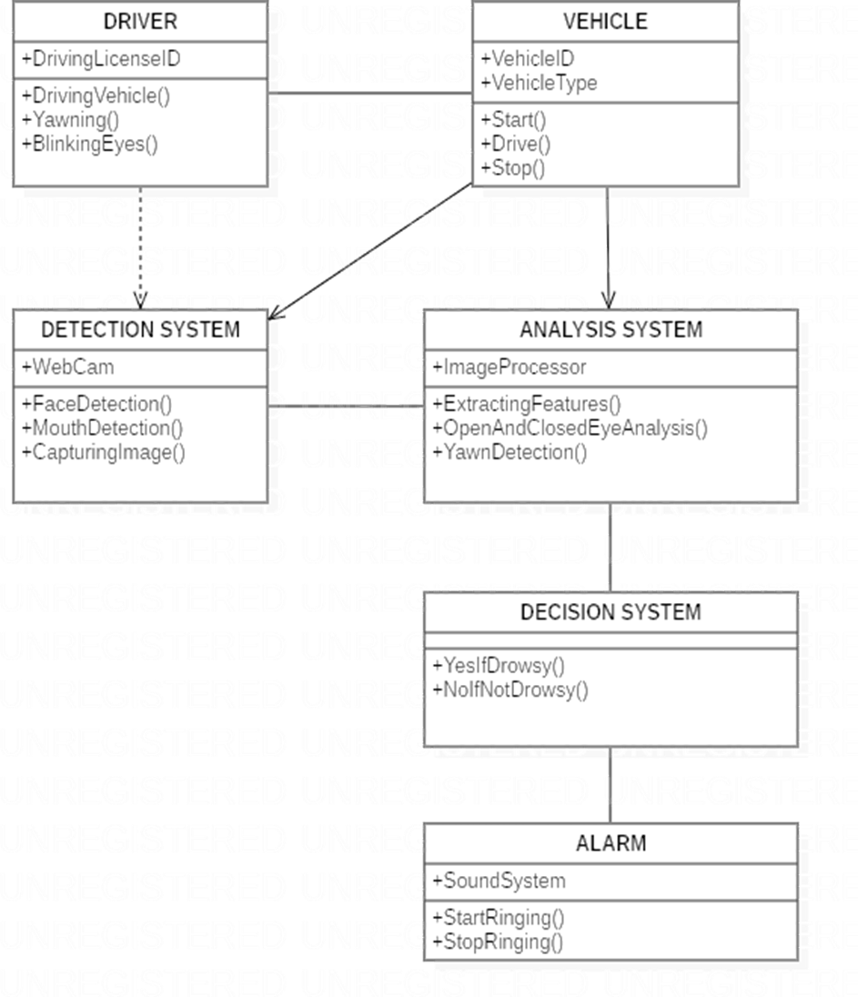

Chapter 6

System Testing

6.1 Test Cases and Test Results

|  |  |  |  |  |
| --- | --- | --- | --- | --- |
| Test  ID | Test case  title | Test Condition | System  Behavior | Expected  Result |
| T01 | NSGY | Straight Face, Good  light | NON  Drowsy | Non  Drowsy |
| T02 | YTGN | Tilted face,  Good light | Drowsy | Drowsy |
| T03 | YTGY | Tilted face, good  light | Drowsy | Drowsy |

Note: Testing is performed manually

Chapter 7

Project Planning

7.1 SYSTEM MODEL

The framework is created utilizing the incremental model. The center  
model of the framework is first created and afterwards augmented in this  
way in the wake of testing at each turn. The underlying undertaking  
skeleton was refined into expanding levels of ability.

At the following incremental level, it might incorporate new execution  
backing and improvement.

Chapter 8

Implementation

• In our program we used Dlib, a pre-trained program trained on the  
HELEN dataset to detect human faces using the pre-defined 68  
landmarks

Chapter 9

Screenshots of Project

9.1 Non-drowsy Person

Chapter 10

Conclusion and Future Scope

10.1 Conclusion

It completely meets the objectives and requirements of the system. The framework has achieved an unfaltering state where all the bugs have been disposed of. The framework cognizant clients who are familiar with the framework and comprehend it's focal points and the fact that it takes care of the issue of stressing out for individuals having fatigue-related issues to inform them about the drowsiness level while driving.

10.2 Future Scope

The model can be improved incrementally by using other parameters like blink rate, yawning, state of the car, etc. If all these parameters are used it can improve the accuracy by a lot.  
We plan to further work on the project by adding a sensor to track the heart rate in order to prevent accidents caused due to sudden heart attacks to drivers. Same model and techniques can be used for various other uses like Netflix and other streaming services can detect when the user is asleep and stop the video accordingly. It can also be used in application that prevents user from sleeping